Council Roadside Reserves Project
  - Asset Management Plan Template
  - for Roadside Vegetation

Integrating Natural Asset Management into
Council Asset Management Systems

Document Tracking
Version No. | Document Author | Reviewed By | Approved By | Last Saved on

Acknowledgements
This document was prepared by Cardno (NSW/ACT) for local councils in NSW as part of the Local Government NSW (LGNSW) Council Roadside Reserves Project (CRR). The CRR project is funded by the NSW Environmental Trust to build the capacity of councils and to improve the management of roadside environmental values in NSW.
November 2019

Cover: Roadside Vegetation in Cowra LGA (Photo: Meredith Brainwood)
This project has been assisted by the New South Wales Government through its Environmental Trust.

Guide to this document
The intention is that land managers will work directly into a copy of this template. Instructions and prompts are in grey text boxes. These should be deleted as you work through the template. The text in red is for guidance purposes only. Additional background and guidance information is provided in green text boxes.
Some standard wording is provided which can be amended based on the need of the project. Deviations and changes to the suggested AMP structure and contents can be made, as necessary, to suit existing Asset Management Systems.
The guidance in this AMP template is for guidance purposes only and the author should undertake his/her assessment of the asset management needs of the roadside sites covered by the AMP.
The AMP should be completed by an informed person with knowledge of asset management and roadside reserves.

Context
This document has been developed to provide NSW councils with a template to assist them in writing Roadside Vegetation Asset Management Plans (AMPs). The overall aim of the document is to help integrate the management of roadside reserve vegetation (roadside vegetation), as natural assets, into pre-existing Asset Management Systems (refer Figure (i)), which are generally dominated by built assets.
This template focuses on vegetation in roadside reserves. Roadside reserves are important due to their potential to contain significant native biodiversity, including ecological communities that may not be represented in national parks, public reserves or private land. They provide valuable wildlife habitat and corridors, especially when linked with other native vegetation remnants in the landscape, which may assist in ensuring roadside environments are sustainable in the long-term.
The template also provides some guidance on how to consider the natural waterways adjoining the vegetation in the roadside reserve. Some councils may choose to do this in the same AMP, however waterway assets could form their own AMP.
Bushland refers to areas of land where the primary land use is native vegetation and natural ecosystems. This can include larger areas of bushland managed for conservation, visual and landscape amenity or catchment protection (e.g. national parks and public reserves) and can also apply to smaller areas of land such as roadside vegetation, riparian vegetation, revegetated landscaped areas, and areas adjacent to parks and recreation areas. Bushland in road reserves can also abut waterways as riparian vegetation, which are often given high value by the local community for their recreation, amenity, heritage and ecosystem values. The main defining element is that the vegetation comprises a mix of trees, shrubs and groundcover generally consistent with vegetation native to the local area.
This AMP template is specific to the asset management of vegetation within the roadside, which is identified through the template as ‘roadside vegetation’, so it is not confused with ‘roadside reserve’, which may be taken to include built assets in roadside areas. It may be possible to apply this AMP template to other bushland areas but the specifics of the guidelines are focussed on roadside vegetation. This template also includes guidance on integrating waterways into the management of roadside vegetation when the vegetation is considered riparian vegetation and abuts a waterway asset.
An AMP is a tactical level document focused on a specific asset class or group, such as roadside vegetation. The objectives of an AMP are to provide the following:
  - A direct line of sight from the organisational objectives to the specific Levels of Service.
  - A clear description of the assets included within the plan, including the boundaries, what these assets do and how this is important.
  - Specify the measurable Levels of Service the asset must satisfy in order to deliver the higher level asset management objectives and business objectives.
  - Define the life cycle strategies including the arrangements for planning, acquisition, operation, maintenance and disposal of the asset.
  - Develop a budget based on asset needs with a comparison of the allocated resources and highlighting any gaps.
  - Identify risks to achieving Levels of Service over the long term, as well as outlining management strategies
  - Define actions to close Level of Service gaps and control risks, including timeframes and resources
An AMP is informed by higher-level strategic documents within the asset management system, including the Strategic Asset Management Plan. In addition, the AMP informs the budgeting process for an organisation by providing an evidence-based forward works program.

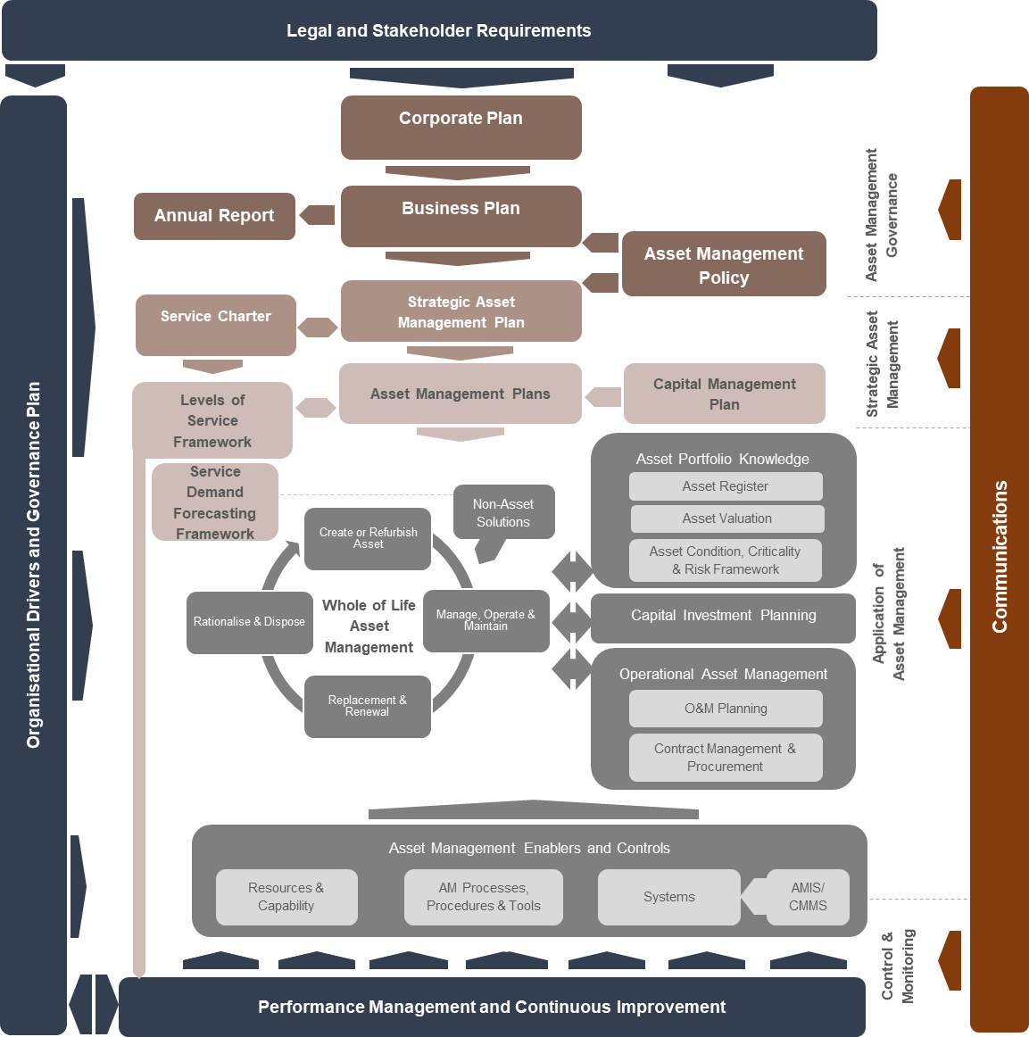
Figure (i): Typical Asset Management System

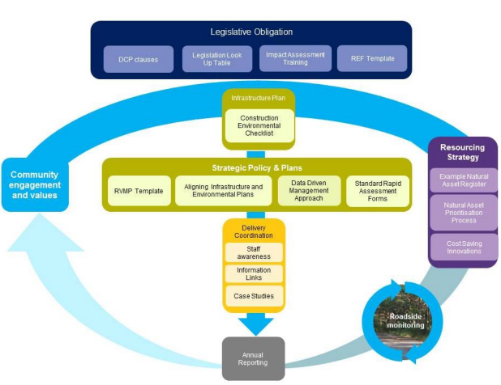

Figure (ii): Asset Management Planning in the Context of the Roadside Environmental Management Framework
There is also a need to align natural assets with built assets through councils’ Integrated Planning and Reporting (IP&R) framework and in particular, through the asset planning process. This is demonstrated in Figure (ii) above.

Asset Management Plan Recommended Structure
The following table of contents is provided to guide the writing of the roadside vegetation AMP. By following the recommended structure, a robust plan that delivers organisational objectives that are linked to asset management objectives can be produced. Data and information may need to be collected by council to ensure all sections can be completed. Deviations from the recommended structure can be made to suit pre-existing Asset Management Systems and AMPs.

Insert logo

Council Name

Asset Management Plan for Roadside Vegetation

Prepared by:

Date:

Contents
1. Summary 3
1.1. Purpose of this Asset Management Plan 3
1.2. Objectives and Goals of this Asset Management Plan 3
1.3. Stakeholders 4
2. Introduction 5
2.1. Background 5
2.2. Community Consultation 5
3. Portfolio Summary 6
3.1. Council Snapshot 6
3.2. Description of the Assets 6
3.3. Heritage Assets 8
3.4. Assets with Highest Consequence of Failure and Risk Rating 9
3.5. Asset Condition 9
3.6. Asset Valuation 10
3.6.1. Valuation methodology 10
3.6.2. Asset Useful Lives 12
3.6.3. Valuation data 13
4. Demand 14
4.1. Demand Impacts on Assets and Services 14
4.2. Environmental Issues and Climate Change 14
4.3. Demand Drivers, Projections and Impacts on Services 14
4.4. Demand Management 16
5. Levels of Service 18
5.1. Stakeholder Expectations 18
5.2. Strategic and Corporate Goals 18
5.3. Legislative and Regulatory Requirements 18
5.4. Current Levels of Service 19
5.5. Desired Levels of Service 19
5.5.1. Customer Levels of Service 20
5.5.2. Technical Levels of Service 21
5.5.3. Conservation Levels of Service 23
6. Lifecycle Management 25
6.1. Risk Management 25
6.1.1. Risk Issues 25
6.1.2. Critical Assets 25
6.1.3. Asset Management Decision Making 26
6.1.4. Lifecycle Decision Making Criteria 26
6.2. Planning and Acquisition 28
6.3. Operations and Maintenance 28
6.3.1. Heritage Asset Maintenance 28
6.4. Renewal 29
6.5. Rationalisation and Disposal 29
7. Financial Summary 30
7.1. Long Term Financial Sustainability 30
7.2. Existing Budgets 30
7.3. Planning, Acquisitions, Operations, Maintenance and Renewals Forecast 30
7.4. Funding Gap 31
7.5. Closing the Gap 31
8. Improvement Program 32
8.1. Future Improvement Actions 32
8.2. Asset Management Plan Review 32
9. References 33
10. Appendices 34

List of Tables
Table 1: Hierarchy for natural assets 6
Table 2: Assets covered by this Asset Management Plan 7
Table 3: Location of roadside vegetation sites covered by this AMP. 7
Table 4: Location of roadside waterway sites covered by this AMP. 8
Table 5: Valuation methdology for waterways 11
Table 6: Valuation data including replacement value for each roadside vegetation asset. 13
Table 7: Demand drivers, projections and potential impacts on services. 15
Table 8: Demand management plan 16
Table 9: Legislative Requirements 19
Table 10: Customer Levels of Service 21
Table 11: Technical Levels of Service 22
Table 12: Conservation Levels of Service 23
Table 13: Decision making criteria used to determine maintenance strategies and funding needs 26
Table 14: Long term sustainability targets 30
Table 15: Existing budget for roadside vegetation assets 30
Table 16: Forecast budget needs for roadside vegetation and waterways 31
Table 17: Future improvement actions 32

Summary
Provide a brief overview of the council as an organisation and of the asset group. In this case the asset is roadside vegetation and any associated waterways. This allows the reader to gain an understanding of the context of the organisation and the assets.
A summary of asset performance and key issues/ risks to the asset group can also be provided in this section.

Purpose of this Asset Management Plan
Outline the value of an AMP in achieving council and organisational objectives. This section can show where the document sits within a wider Asset Management System document hierarchy.

Objectives and Goals of this Asset Management Plan
List the objectives and goals of the AMP.
The objective of the AMP is to show that the assets within the asset class positively contribute to the delivery of council and organisational objectives. This should be linked with the asset management objectives if higher level documents exist in the Asset Management System, e.g. Strategic Asset Management Plan.
For example,
“The objective is to establish a document to guide the planning, creation, construction, maintenance and operation of the roadside vegetation assets for council to provide services to the community while conserving the valuable asset”. (Muswellbrook Shire Counci)
The goals relate to the asset outcomes to be delivered through the AMP.

LGNSW has developed the Council Roadside Environmental Management Framework (CREMF), which aims to streamline roadside environmental management in councils. The framework looks at councils' many complex road responsibilities holistically and aims to support councils in NSW to navigate complex legislation, meet regulatory requirements, minimise risk and make the process of improving roadside environments more efficient and cost-effective.
Embedding roadside environmental management within councils’ management framework (IP&R) has the benefit of streamlining the process by linking it with existing planning, reporting and asset management processes. This is the rationale for identifying the vegetation in roadside reserves (roadside vegetation) as an asset.

The NSW Roadside Environment Committee has also produced a range of documents focused on planning and managing roadside and other linear reserves. These publicly available documents provide useful guidance in defining objectives and goals for managing linear reserves, as well as providing advice on management strategies. Many councils may have already developed roadside environmental management plans that would assist in finalising the roadside vegetation AMP.

Stakeholders
Internal stakeholders for the roadside vegetation sites, include:
List the key stakeholders to the assets, particularly internal stakeholders. Their interest in the assets can be further elaborated here. The following may be applicable:
  - Councillors
  - Asset managers
  - Environmental scientists/ managers
  - Weed officers
  - Roadside maintenance crews
  - Compliance officers
  - Planners
  - Subject matter experts
  - Emergency management staff
  - Financial Managers

External stakeholders include, but are not limited to:
  - Adjacent landowners
  - Regulators
  - Special interest groups
  - Emergency services
  - Landcare groups
  - Transport for NSW (incorporating the former Roads and Maritime Services)
  - Utilities
  - Biodiversity Conservation Trust
  - NSW National Parks and Wildlife Service (NPWS)
  - NSW Department of Planning, Industry and Environment (DPIE; formerly the NSW Office of Environment and Heritage)
  - NSW Department of Primary Industries (Fisheries) (NSW DPI)

Introduction

Background
Put the AMP in context with other relevant council strategic, financial and planning documents. List the relevant documents and provide commentary on their relationship to the AMP.

Community Consultation
Where community consultation has been undertaken to develop the AMP (particularly levels of service and forward works costs) summarise the outcomes and main points.
Otherwise, indicate that the AMP has been prepared to facilitate future community engagement.

Portfolio Summary

Council Snapshot
Provide a brief description of the council area characteristics, using any relevant maps or figures. The snapshot should set the asset into the context of the council area. For example:
  - Length of road corridor/waterway
  - Primary industry in the area
  - Demographics
  - Climate
  - Unique features, etc.
This section could also state the importance of roadside vegetation to the council area/ local context.

Description of the Assets
Provide a more detailed description of the asset in this section.
To set the asset in context, include a table to show the asset hierarchy adopted for the natural asset class (this could be removed as natural asset AMPs mature over time). The generally accepted hierarchy for natural assets is shown in Table 1 below.

Table 1: Hierarchy for natural assets
Asset Class | Asset Type | Asset Component | Asset subcomponent
Natural Assets | Vegetation | Roadside reserve  Riparian reserves | Trees  Shrubs  Grasses
 | Trees | Street trees  Roadside trees  Reserves
 | Water ways | Creek  River  Ocean  Estuary  Lake  Wetland  Pond | Riparian edge  Weir  Bed  Water  Bank  Aquatic vegetation

Summarise at a high level the assets covered by the AMP. Provide an overview of the characteristics of the asset, such as vegetation type, length of sites, estimated areas and the estimated replacement value. An example is provided in Table 2.
Table 2: Assets covered by this Asset Management Plan
Roadside | Main vegetation type | Length (m) | Estimated Area (m²) | Estimated Replacement Value ($)
Whiting Road | Treed | 2,660 | 3,012,405 | 14,862,969
House Rock Road | Treed | 2,990 | 394,000 | 1,883,187
Ridgelands Ave | Treed | 3,350 | 829,357 | 3,515,734
Cedar Road | Treed | 2,000 | 694,940 | 2,353,894
Mango Road | Treed | 900 | 73,552 | 985,967
Roxburgh Road | Treed | 3,400 | 770,000 | 4,289,000
Totals |  | 15,300 | 5,774,254 | 27,890,751

Follow this with an explanation on any restrictions on the asset coverage. This will mainly relate to the data set available. For example, there may only be data for a few sites across the council area.
Insert a table locating the roadside vegetation/waterway sites covered by the AMP. Include relevant details for the asset register or data set used, for example, see Table 3 and Table 4 below.
  - Site number/waterway identification number
  - Waterway asset component and subcomponent
  - Road name
  - Location description (including waterway classifications in accordance with the NSW Department of Primary Industries (Fisheries) Policy and Guidelines for Fish Habitat Conservation and Management - and waterway length or area)
  - Location coordinates (start and end coordinates for waterways)
  - Roadside vegetation site area

Table 3: Location of roadside vegetation sites covered by this AMP.
Site Number | Road name | Location Description | Roadside length | Latitude | Longitude | Calculated Area (m²)
1 | XYZ Road | North side of road | 500 m | -32.26352965 | 150.7331107 | 34,750
2 | ABC Road | South side of road | 1000 m | -32.20458224 | 150.7624128 | 30,770
3 | MNO Road | East side of road | 750 m | -32.20387066 | 150.7481678 | 324,970

If Site 2 from the above table consisted of riparian vegetation and the adjacent waterway/s require consideration, then an additional table, like the one below, would identify the waterway/s.

Table 4: Location of roadside waterway sites covered by this AMP.
Site Number | Waterway Id. Number | Waterway Component | Waterway Sub component | Waterway length (or area) | Waterway Longitude and Latitude | Road Name | Waterway Classification
2 | 001 | Creek | Bed | 1000 m | -32.26352965  150.7331107 | XYZ Road | Class 1
2 | 002 | Pond | Bed | 100 m² | -32.20458224  150.7624128 | ABC Road | Class 4
2 | 003 | Wetland | Bed | 100 m² | -32.20458224  150.7481678 | MNO Road | Class 2

Where more data is available, include:
  - Asset useful lives (derived from historical council data relating to the life of roadside vegetation assets, or from published data). For other asset classes, useful life is a key input to decision making, particularly predicting the timing of an asset renewal. For roadside vegetation, this data may not be as useful but may assist in long term planning.
  - Flora and fauna of high conservation value e.g. threatened species or ecological communities present in the area.
  - Whether the waterway is natural or man-made.
  - Condition of roadside vegetation. The Rapid Assessment Method (RAM), developed by Local Land Services and LGNSW to assess linear reserve vegetation is a tool to undertake a condition assessment and assign a conservation value. Other resources include consistency with vegetation condition benchmarks within the NSW Government’s BioNet Vegetation Classification system (noting these are more complex and require more vigorous data collection).
  - Descriptor of the main type of vegetation present (ideally consistent with a Plant Community Type definition within the NSW Government’s BioNet Vegetation Classification system for standardisation). The council’s roadside vegetation management plan (where these exist) will also provide this detail.

Heritage Assets
Roadside vegetation assets can also have heritage or cultural significance. These may be listed in Council’s LEP or may be identified during a consultation process. These should be identified here and can include, but not limited to:
  - An Aboriginal object
  - A building, work, relic or tree
  - Heritage conservation areas

Assets with Highest Consequence of Failure and Risk Rating
Complete this section where risk assessment data is available. An intergenerational view of roadside vegetation and associated waterways is needed when assessing consequences of failure. The consequence of the failure (e.g. complete invasion of weeds, loss of threatened plant species or loss of embankment) may have more impact on future generations rather than the current generation.
Assets with a high risk rating should have plans in place to manage the risk similar to the mitigation plans developed for high consequence risks. These plans may also include strategies to reduce or eliminate risk, as well as mechanisms to report the risks and the exposure they pose to council.

Assets with a high consequence of failure are likely to be critical assets, but will not necessarily have a high risk score. Due to the impact of the failure, these assets should have mitigation plans or modified maintenance strategies to minimise the risk of failure. It is important to take intergenerational effects into account when considering the risk of failure for roadside vegetation and associated waterways. The failure may not be apparent in the generation it occurred but may still pose a high consequence.

Asset Condition
Provide a definition or explanation on the current condition of roadside vegetation and associated waterway assets (if appropriate). This can be displayed in a tabular form, or using graphs.
Condition data can be aggregated up to an overall summary and displayed for each roadside site. The extent of detail provided here should be assessed on the variability of the dataset. The greater the variability the greater granularity of detail required.
Provide a definition or explanation as to how the condition was assessed (e.g. using the RAM) and what the condition ratings mean.
Condition description of roadside vegetation assets can include:
  - Proportion (e.g. percentage (%) cover) of weed invasion
  - Density of vegetation elements
  - Vegetation complexity (e.g. by vegetation maturity or type, % of exotic vs native vegetation)
  - Presence of threatened species or communities
  - Habitat loss and clearing
  - Evidence of dumping
  - Fire evidence
  - Storm damage

Condition description of waterway assets can include:
  - Degree of scouring
  - Storm or surge damage
  - Water quality
  - Presence of aquatic vegetation or fauna
  - Health of riparian vegetation
  - Flow rate of the water
  - Natural features such as pools and riffles
  - Erosion
  - Presence of rocks and logs or other fish habitat features
  - Occurrence of any obstructions to fish passage
Condition descriptions of waterways could be collected to inform the management of the abutting roadside reserve. For example, the presence/absence of aquatic vegetation may be attributed to the condition of the riparian vegetation within the roadside reserve.

Note that the NSW Government’s BioNet Vegetation Classification system provides condition benchmarks and a methodology (Biodiversity Assessment Method) that could be used as a standard and repeatable approach to scoring condition of vegetation. To use this system, Plant Community Types would need to be identified and survey work completed in accordance with the methodology. It also provides guidance on the management actions that may be required to improve roadside vegetation condition.

Asset Valuation

Valuation methodology
This section explains the financial valuation methodology applied to create the replacement cost.
Roadside vegetation and natural assets are important as they contribute to environmental, community and heritage value. However, the valuation provided in this AMP is the financial valuation only and equates to the cost of replacement (you may prefer to delete the following and provide your own methodology here).
Roadside vegetation assets have long useful lives, for this reason, depreciation is not applied to roadside vegetation in calculating the valuation. Written down value is assumed to equate to replacement cost.
The generic methodology for deriving the financial value of the roadside vegetation sites is:
  - Calculate area of roadside vegetation for each roadside vegetation site – use council data or any relevant GIS layers for example, Near Maps/Google Earth.
  - Choose a consistent sample area (e.g. 20 m x 50 m) and count the number of trees, shrubs and % covered by groundcover for each site using the same sample area size and record for each site. Use the dataset (or asset register) where possible or estimate using any available aerial photography, GIS layers or Google maps (or equivalent) where no collected data is available.
  - Find the average number of trees, shrubs and % covered by groundcover over each of the sample sites. This average value will be used to derive the unit rate (per m²) for roadside vegetation.
  - Assess plant costs of each element of the roadside vegetation (i.e. tree, bushes, and grasses) by deriving the cost of planting each element new. Assume the largest plant/seedling/sapling size as a basis for the price. Do not try to cost the like for like replacement of mature roadside vegetation elements. It is highly unlikely a like-for-like replacement will be viable or even possible. Derive costs from relevant contract Schedule of Prices, local nurseries, or Rawlinsons Australian Construction Handbook where no other data is available. Sum the total plant costs for the sample area and divide by the average area of the site to determine unit rates.
  - To derive the unit rate for roadside vegetation, add a cost for preliminaries to the rate derived for plant costs. Preliminaries include removal of old vegetation and ground preparation. This can be extracted from Rawlinson’s (pg229 in the 2019 edition) or directly from relevant contract Schedule of Prices.
  - Add a percentage to cover overheads to the unit rate (use 20%, if no greater accuracy can be derived). This is the final unit rate $/m² to be used to find replacement costs for each site.
  - Apply unit rates to the entire area of all the sites. Replacement cost = area x unit rate.
List valuation assumptions. These might be:
  - Depreciation is not applicable to roadside vegetation assets due to their long lives.
  - Plant establishment costs (initial watering, etc.) are funded through an operational or maintenance budget and not included in this replacement cost assessment.
  - Plants can be sourced locally that are consistent with those already present on the roadside reserve site.
Waterways and natural assets are important as they contribute to environmental, community and heritage values. However, the valuation provided in this template is the financial valuation only and equates to cost of replacement.
The generic methodology for deriving the financial value of a waterway is:
  - Value each waterway individually.
  - Identify the components and sub components of each waterway and confirm they are not covered by other asset classes, such as drainage, minor structures or land.
  - Calculate the replacement cost in the sub components and then sum together to give the total replacement cost.
Table 5: Valuation methdology for waterways
Waterway asset subcomponent | Suggested valuation methodology
Water | Estimate the volume of water at average capacity contained in the waterway and obtain price to extract and transport water from a similar waterway.  Include overheads.
Riparian edge | Identify the plant species present and calculate cost of purchase of seedlings, ground preparation, planting and overheads
Aquatic vegetation | Calculate the type of vegetation and the density. Source prices from recent contracts (where manmade waterways were constructed).  Include preparation of the waterway for planting and overheads
Weir | Calculate the replacement cost by assuming an equivalent construction of the natural weir by rock or concrete. Assess the volume of material needed. Include cost of the material, transport, ground preparation, handling and placing.
Bed | Calculate the surface area of the waterway bed. Then either:  Assume a depth of rock and estimate the volume of rock required to replace the bed. Price the rock from local sources  Assume a depth of fill material and calculate the volume of fill required then price from previous contract data or a local quarry  Assume a depth of concrete and estimate volume then cost of replacing with concrete. Include formwork and reinforcing.  Assume preparation of the ground and possible use of geotextiles. Include overheads
Bank | Treat similar to a slope or earthworks. Assess the volume of the bank and identify material (fill or rock). From recent contracts extract rates for rock, concrete or fill and apply to the volumes.  Include overheads, transport to site, handling and placing, materials.

Note that NSW DPI (Fisheries) provide a framework for compensating for the loss of fish habitat based on area of habitat lost and the habitat conservation value within the Policy and Guidelines for Fish Habitat Conservation and Management. This framework is based to some degree on the cost of replacing lost habitat and may be of value in calculating habitat value of natural watercourses.

Asset Useful Lives
Detail the asset useful life and remaining useful life, if data is available Roadside vegetation and associated waterways are considered to have an extensive useful life. The following is suggested where no other data is available:

Asset component | Useful life
Trees | 80 – 200 years
Shrubs | 40 – 100 years
Grasses | 25 – 40 years
Waterways | 200+ years

For the replacement of roadside vegetation assets, the useful life is not required to calculate the replacement cost. Instead, the replacement value can be determined by using the cost of replacing the asset type with the most mature plant available from local nurseries inclusive of planting costs.
For the replacement of waterway assets, the useful life is also not required to calculate the replacement cost. Instead, the replacement value can be determined by using the suggested methodologies above, which do not require knowledge of the condition of the asset, nor the remaining useful life. Due to the long useful life of a waterway no depreciation is applied over the life of the waterway. In this way, the written down value will equal the replacement cost.
A waterway may appreciate in value over its life time, especially if it grows and continues to provide increased environmental value. However, the cost of replacing the waterway does not change with asset age.

Valuation data
Valuation data including replacement value for each roadside vegetation asset is listed in Table 6 below.
Table 6: Valuation data including replacement value for each roadside vegetation asset.
Site Reference/Waterway | Sub  component | Area (m²) | Unit rate ($/ m²) | Replacement Cost ($) | Accumulated Depreciation ($) | Annual Depreciation ($) | Written Down Value ($)
001 |  | 1000 | 6 | 100,000 | 0 | 0 |  | 100,000

Demand

Demand Impacts on Assets and Services
Demand for new and enhanced services are managed through a combination of managing existing assets, augmenting existing assets and providing new assets to meet demand and demand management.
Document the demands placed on roadside reserve vegetation and associated waterways and then derive management strategies to address those demands. The demands identified should be specific to the council area and not a generic listing.

Demand impacts on asset requirements can arise from climate and environmental changes, population growth/decline or changes in regulatory expectations. In the AMP, anticipated changes in demand and their impact on the asset base should be captured, as should relevant mitigation strategies. If there is a large demand on an asset, this can lead to the following:
  - A shorter useful life, as the asset is being consumed at a faster than expected rate
  - Increases in maintenance cycles due to higher than expected consumption

Environmental Issues and Climate Change
Climate change is an important consideration in demand forecasting and asset planning. A change in climate could lead to changes that impact roadside vegetation and/or waterway assets. Factors include:
Choose from the following, or add your own:
  - Increased frequency and severity of phenomena such as extreme rainfall, wind and thunderstorms that have the potential to cause significant damage to natural assets and open spaces. This could result in reduced access to these areas or the requirement to remove fallen debris which is impeding use
  - Periods of low rainfall leading to drought, which could have impacts on the biodiversity of the natural roadside vegetation area. This may require human intervention to help maintain the area
  - Potential for increase in bushfire intensity and the frequency of bushfires having a direct impact on roadside vegetation assets through either fire events or pressure to clear/ modify assets for fire protection/ mitigation purposes
  - Increasing temperature in urban areas can increase the demand for green spaces and roadside vegetation to combat the urban heat island effect

Demand Drivers, Projections and Impacts on Services
The purpose of identifying demand drivers is to identify factors and trends that may influence the way council’s assets are used in the future compared to the present. In identifying demand drivers and projections, the planning horizon should be considered and included as well as any data used, modelling and assumptions. Demand forecasting should be integrated into the development and reviewing of asset management plans and documented here.

Demand drivers to consider for roadside vegetation include:
  - Legislation, eg Biodiversity Conservation Act 2016
  - Traffic
  - Road maintenance
  - Road and public safety (e.g. clear zones, power lines, playgrounds, etc.)
  - Neighbouring farmland
  - Changes in community expectations
  - Population
  - Demographics
  - Agricultural, mining, industrial activities
  - Seasonal factors
  - Environmental awareness
  - Climate change
  - Economic factors (eg budget or financial constraints)
  - Habitat
  - Corridors

Table 7: Demand drivers, projections and potential impacts on services.
Demand Driver | Present position | Projection | Impact on service
Agricultural activity | Widespread farming areas across the LGA | A reduction on levels of faming activity and numbers of rural residents, particularly in mining areas | Opportunities to regenerate roadside vegetation and provide improved access and corridor connectivity
Seasonal factors | Reasonably distinguished seasons | Rainfall to decrease in spring and winter but increase in autumn  Number of hot days to increase and the number of cold nights will decrease  Fire danger index to increase in summer, spring and winter | Stress on the vegetation to cope with extremes in temperature and lower rainfalls, plus direct and indirect impacts of fire.

Demand Management
Provide an outline of council’s strategies or activities to influence demand for services and assets. This includes those activities undertaken as part of sustainability initiatives and/ or to avoid or defer required asset investment, this can include non-asset solutions such as changing public access to a roadside vegetation area.
Using the demands identified in the previous section (Table 7) briefly describe the demand management plans for each in Table 8 below.

Demand management actions should be considered when determining the annual budget request for roadside vegetation. Some management actions may require ongoing or longer term actions and should feature in all future budget requests.

Table 8: Demand management plan
Demand Driver | Impact on service | Demand Management Plan
Agricultural activity | Opportunities to regenerate roadside vegetation and provide improved access and corridor connectivity | Identify areas for new or expanded roadside vegetation areas, including trees.  Increase investment in new roadside vegetation to improve extent and connectivity
Seasonal factors | Stress on the vegetation to cope with extremes in temperature and changes in rainfall patterns, plus direct and indirect impacts of fire. | Minimise other stresses on roadside vegetation such as litter and weeds to allow vegetation to improve its resilience to seasonal factors  Increase connectivity with other roadside vegetation areas to facilitate species movement.

Example management actions:
  - Planting of a buffer zone of sacrificial vegetation to protect the natural roadside vegetation from immediate effects of traffic.
  - Increased inspection frequencies to identify weeds before they spread.
  - Construct guardrails at known crash sites to protect the roadside vegetation.
  - Implement the Road Marker Scheme to limit inappropriate maintenance strategies on selected sites.
  - Controls over maintenance vehicles and equipment cleaning to remove seeds and weeds.
  - Agreements with landowners for management of weeds on private land.
  - Council funding of weed treatment on private land.
  - Keep abreast of potential changes to legislation and plan ahead as far as possible.
  - Lobby government for changes to allow optimal management of roadside vegetation.
  - Greater public education as to the value of roadside vegetation and how to look after it while still enjoying the benefits.
  - Increasing investment in protecting roadside vegetation to allow it to retain or increase its conservation value.
  - Preparation of management plans for roadside vegetation areas.
  - Opportunity for community support for greater investment in maintaining existing roadside vegetation and planting of new.
  - Opportunity to leverage volunteers to help with roadside vegetation maintenance.
  - Development approvals applying conditions on mining activities that have nil or positive impact on roadside vegetation.
  - Identify areas for new or expanded roadside vegetation areas.
  - Increase investment in new roadside vegetation to improve connectivity.
  - Minimise other stresses on roadside vegetation such as litter and weeds to allow vegetation to improve resilience to seasonal factors.
  - Increase connectivity with other roadside vegetation areas to facilitate species movement.
  - Maintain all fire breaks (the road) to minimise any fire spreading – including trimming over hanging branches back to the road or verge edge.
  - Reduce the hazard through controlled burning, mechanical clearing or reduce the ground fuel by hand.
  - Ensure the Bush Fire Management Plan takes account of the status and ecosystem value of the roadside vegetation areas.
  - Limiting access to the roadside vegetation sites during high fire risks periods.
  - Gain community support and understanding for new and extended roadside vegetation areas and greater investment in maintaining existing roadside vegetation.

Levels of Service
LoS are defined within the International Infrastructure Management Manual (IIMM) as “what the organisation intends to deliver. Levels of Service define attributes of service from a customer point of view.”

Document the Levels of Service (LoS) council intends to deliver through the assets. There should be line of sight from delivery of LoS through to achievement of Asset Management objectives and ultimately the delivery of organisational objectives.
LoS might be identified from pre-existing Asset Management System documents including:
  - Strategic Asset Management Plan
  - Roadside Vegetation Management Plans
  - Community Strategic Plan
  - Maintenance contract requirements

Stakeholder Expectations
State the current understanding council has of its stakeholder expectations, how stakeholders understand the costs associated with providing a service for roadside vegetation and waterway assets and any completed/planned stakeholder consultation. Stakeholder consultation may be in the form of a community satisfaction survey.

Strategic and Corporate Goals
List the elements of relevant strategic documents that relate to the development of Levels of Service (LoS) for roadside vegetation asset management. This should include the Asset Management Policy, the Strategic Asset Management Plan, the Community Strategic Plan and other plans and policies such as a Roadside Environmental Management Policy.

This provides the line of sight from the AMP to strategic guidance. Ultimately if a LoS cannot be aligned with council’s strategic direction the validity of allocating funds to meet the LoS should be assessed in detail.

Legislative and Regulatory Requirements
List the main acts, regulations and code specific to roadside reserve vegetation and associated waterways. Typically, these are the minimum service standards. Councils will need to be compliant with all appropriate acts, regulations and codes.

Table 9: Legislative Requirements
NSW Acts | Commonwealth Acts
Biodiversity Conservation Act 2016 | Aboriginal and Torres Strait Islander Heritage Protection Act 1984
Biosecurity Act 2015 | Environmental Protection and Biodiversity Conservation Act 1999
Coastal Management Act 2016
Environmental Planning and Assessment Act 1979
Heritage Act 1977
Crown Lands Management Act 2018
Local Government Act 1993
Local Land Services Act 2013
Pesticides Act 1999
Protection of the Environment Operations Act 1997
Rural Fires Act 1997
National Parks and Wildlife Act 1974
Fisheries Management Act 1994
Roads Act 1993
Water Management Act 2000
Infrastructure – State Environment Planning Policy

Current Levels of Service
List any current LoS. These are likely to be recorded in any roadside vegetation maintenance contracts or from the strategic documents identified in the previous section.

Desired Levels of Service
It is desirable to have a sufficient set of LoS statements to encompass all aspects of managing the assets covered within the AMP. Desired Levels of Service have typically been identified but may not have been implemented into the way an organisation manages its assets, including reviewing maintenance activities to ensure the LoS can be achieved.
During the development of an AMP, it is common to identify desired LoS, which may be derived from:
  - Legislative requirements and applicable Australian Standards
  - Stakeholder expectations from research and feedback
  - Strategic requirements

Three types of Levels of Service have been determined:
- Customer Levels of Service -- measure how the community receives the service and whether the organisation is providing community value. Customer level of service measures used in the asset management plan are:
- Quality How good is the service?
- Function Does it meet users’ needs?
- Capacity/Utilisation Is the service over or under used?
These are summarised in Table 10.
- Technical Levels of Service - Supporting the customer service levels are operational or technical measures of performance. These technical measures relate to the allocation of resources to service activities that the organisation undertakes to best achieve the desired community outcomes and demonstrate effective organisational performance. Technical service measures are linked to annual budgets covering:
- Operations – the regular activities to provide services such as data gathering, performance measurement, reporting, management systems (GIS, valuation), etc.
- Maintenance – the activities necessary to retain an asset as near as practicable to an appropriate service condition (e.g. pruning),
- Renewal – the activities that return the service capability of an asset up to that which it had originally or a lower capability if specified in the Levels of Service (e.g. replanting)
- Upgrade – the activities to provide a higher level of service (e.g. denser bushland) or a new service that did not exist previously (e.g. new area of roadside vegetation).
These are summarised in Table 11.
- Conservation Levels of Service – describing the quality of biodiversity (e.g. density of flora and fauna, degree of weed infestation or level of restoration). These are summarised in Table 12.
Asset managers plan, implement and control Technical Levels of Service to aid achievement of the Customer and Conservation Levels of Service.

Customer Levels of Service
These LoS assess whether a service is being provided and typically relate to how the user perceives the outcome against what they want in terms of safety, quality, reliability, responsiveness, cost-effectiveness, legislative compliance, etc.
In accordance with the definitions above. Table 10 documents the recommended Customer Levels of Service to be achieved for the roadside reserve sites.

Table 10: Customer Levels of Service
Service Aspect | Level of Service | Measure | Method of measurement | Target | Current Performance
Safety | Roadside vegetation facilities are safe to use for intended purpose by maintenance staff, general public etc. | Number of reports of incidents in roadside vegetation areas | Audit of reported incidents | Decreasing trend in number of reported incidents
Access | Roadside vegetation is accessible by all users | Number of roadside vegetation sites with walking, cycling or vehicle access points.  Number of roadside vegetation areas with provision for walking or cycling through. | Inspection of both access points to roadside vegetation and availability of paths for traversing through roadside vegetation for pedestrians and cyclists. | 70% of roadside vegetation areas with a safe access point by vehicle, pedestrian or cycle.  75% of all roadside vegetation with an access point to have clearly defined paths through the area.
Compliance | Ensure all roadside vegetation assets comply with all relevant legislative and regulatory provisions | Percentage compliance with all Legislative Acts, Regulations and Codes. | Periodic specialist inspections. | All non-compliant roadside vegetation assets are on works programs for rectification.

Insert achievement of the LoS in the ‘Current Performance’ column when data is available.

Technical Levels of Service
Technical measures that are typically internal measures, focus on how the service is provided and parameters around the service. These measures can influence resource allocation and determine the budgets for providing the service to meet the community’s expectations. Technical measures to consider implementing include:

Table 11: Technical Levels of Service
Service Aspect | Level of Service | Measure | Method of measurement | Target | Current Performance
Maintenance | Roadside vegetation areas are maintained and managed in accordance with good practice guidelines | Maintenance specifications are reviewed each year and updated in accordance with new good practice guidelines | Audit maintenance specifications against current good practice guidelines | Maintenance specifications reflect good practice guidelines published within the last 24 months
Function & Capacity | There is a long term plan to ensure future provision of the service | A 20 year plan is in place, approved by appropriate authorities, and is reviewed and updated every 3-5 years. | 3-5 years review | Plan is developed and reviewed in accordance with program
Function | Maintenance and operational risks are recorded and monitored | Council to maintain Risk Register and monitor effectiveness of risk treatments with no asset assessed as extreme | Annual review of risk register | Register maintained and no extreme risks on register for more than one month
Renewals | Roadside vegetation assets are renewed (i.e. rehabilitated) at appropriate times | Identified renewals are undertaken within the programmed year of renewal | Audit renewal program | 85% of renewals are undertaken in the programmed year
Condition | Roadside vegetation is maintained to meet user expectations | Weed and rubbish removal from roadside vegetation is carried out in accordance with contract requirements | Audit of contractor/council activities | All weed and rubbish removal requirements met by Contractor
Operation and Maintenance | Maintenance issues attended to within response times | Reactive works orders are completed within the required response times | Percentage of works orders completed within the required response time | >95% close out of responsive work orders within the required response times
Operation and Maintenance | All roadside vegetation has appropriate maintenance regimes | Completion of planned maintenance per specified requirements | Contractor performance reviews | >98% of planned maintenance is completed each month

Insert achievement of the LoS in the ‘Current Performance’ column when data is available.

Conservation Levels of Service
Conservation measures typically focus on the environmental or ecosystem requirements of the roadside vegetation assets. These measures can influence resource allocation and determine the budgets for providing the service to meet expectations.
The recommended Conservation Levels of Service are listed in Table 12.
Table 12: Conservation Levels of Service
Service Aspect | Level of Service | Measure/Methodology | Method of measurement | Target | Current Performance
Conservation value | Improve conservation value | Establish current conservation value and increase | Assess conservation value every 5 years | Improve conservation value by 5% in 5 years
Conservation value | Improve habitat connectivity | Identify key connectivity corridors and establish or repair in priority order | Assess habitat connectivity every 5 years | Improve habitat connectivity by 5% in 5 years
Conservation condition | Protect roadside vegetation area from human harm | Conservation condition is not harmed | Field inspection of conservation value | Conservation value does not decrease through harm from human factors.
Conservation condition | Prevent deterioration of conservation condition of the roadside vegetation | Conservation condition does not deteriorate | Field inspection of conservation condition | No negative change in conservation condition.

Insert achievement of the LoS in the ‘Current Performance’ column when data is available.

Lifecycle Management

Risk Management
Council’s approach to identifying, evaluating and managing risks is often documented in their risk management framework. Councils will have a corporate risk management process and there may be additional processes to further assess operational or asset specific risks.
Document how a risk assessment is completed for roadside vegetation, and how this leads to interventions which will be covered in Lifecycle Decision Making Criteria.

Risk Issues
Where a risk assessment of the roadside vegetation covered by the AMP has been undertaken, list the significant risk issues (e.g. bushfire risk, bank collapse caused by flooding, etc.).
This information should be used to determine actions to be funded by capital or operational & maintenance budgets.

Critical Assets
Not all roadside vegetation or waterways may be considered to provide the same service to the community. Some may be identified as critical assets. Any roadside vegetation or waterways that have been identified as critical should be listed here. A higher LoS may be applied to critical roadside vegetation. Critical roadside vegetation may be:
  - Provide habitat for rare or threatened species of fauna.
  - Contain rare or threatened flora species.
  - Contain Endangered Ecological Communities.
  - Provide roadside vistas for traffic entering or exiting a town.
  - Be iconic to the town or road they are adjacent to.
Critical waterways may be:
  - Be part of a wider important water network.
  - Be identified as key fish habitat.
  - Provide roadside aesthetics.
  - Be iconic to the town or road they are adjacent to.
  - Be the only source of water in the area.
  - Be a Ramsar/DIWA/Coastal wetlands.
  - Be habitat for JAMBA/CAMBA etc. species.

Asset Management Decision Making
Asset management decision making should be evidence based and relate to criteria in the AMP covered to date. That is:
  - Roadside vegetation/waterway condition
  - Demands on roadside vegetation/waterways and demand management strategies/actions
  - Levels of Service
  - Risk and criticality

Table 13: Decision making criteria used to determine maintenance strategies and funding needs
Source | Criteria | Maintenance Strategy | Funding Need
Condition | Condition rating >4 | Assess compliance with LoS  Review maintenance strategy to confirm appropriateness | Increase maintenance budget where a change is made to the maintenance strategy
Demand | Clear zone weed spraying affecting roadside vegetation | Implement Roadside Marker Scheme | Submit a business case for the implementation of the Roadside Marker Scheme and seek funding accordingly
Level of Service | Improve habitat connectivity | No change | Submit a business case to plant new roadside vegetation to connect roadside vegetation site XYZ to roadside vegetation site ABC
Risk | Risk score > High | Adjust relevant maintenance strategies to reduce risk to < high | Estimate cost of adjustment to the maintenance strategies and seek budget

Lifecycle Decision Making Criteria
This section will outline council’s process for managing the asset lifecycle through planning, acquisition, management, renewal and disposal.
The lifecycle decision-making process focuses on optimising the life of the roadside vegetation and associated waterway assets. The decision-making process through each phase of the lifecycle is outlined below:
- Planning. This involves the identification of need, options analysis and justification of the proposal. This process can include seeking advice from professionals on proposals, etc.
- Acquisition. This is the purchase and planting of the roadside vegetation based on the decisions made in the planning phase
- Operate and Maintain. The maintenance strategy is to maintain the roadside vegetation to the relevant standard to meet the LoS. This includes regular inspections, maintenance and reporting. Inspections are to be undertaken to understand where the roadside vegetation assets are within their lifecycle and their condition to enable adjustment of maintenance regimes where necessary.
- Renewal. Asset condition will deteriorate over a long period of time, depending on asset demand and require a renewal. Renewal often forms a large component of the budget and correct information at this stage of the process is paramount to making cost effective decisions that will deliver the required levels of service. Roadside vegetation and waterway assets are considered to have long useful lives thus asset renewal is generally lower frequency, if at all (for those that do not deteriorate).
- Rationalisation and Disposal. Roadside vegetation has a long asset life if maintained adequately and demands managed. However, elements of roadside vegetation also interact with other assets in the road reserve and may pose safety threats to road users. Disposal of roadside vegetation may be required if it sits within the road clear zone or tree roots are causing pavement deterioration or infiltrating underground services.
The typical asset lifecycle is shown Figure 1.
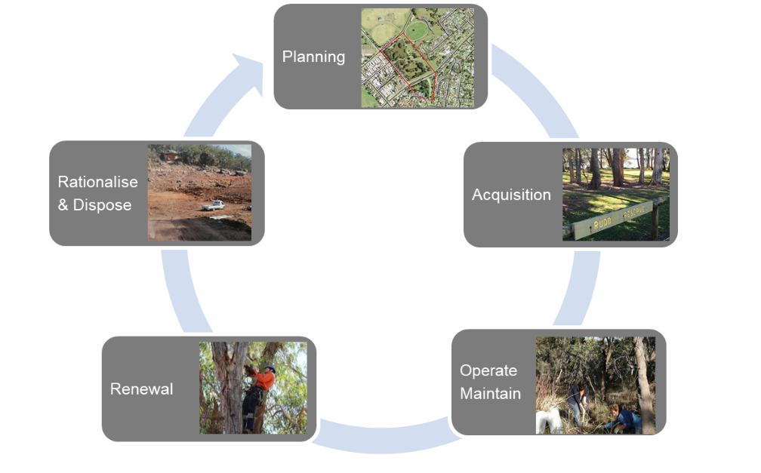
Figure 1: Typical Asset Lifecycle

Planning and Acquisition
Include details on how council identifies new asset acquisition needs, including intervention criteria, how they are assessed including procurement options and who in the organisation endorses those needs and progresses them into the capital program.
The planning and acquisition process should include consideration of:
  - Water efficiency considerations
  - Roadside vegetation resilience in terms of climate change, water and nutrients
  - Edge effects
  - Corridor connectivity
  - Road safety clear zone considerations
  - Underground services and other assets within the road reserve
  - Neighbouring land
  - Consideration of ground conditions such as salinity or acid sulphate soils
  - Roadside vegetation resistance to pests and diseases
  - Purpose of the waterway in the roadside

Operations and Maintenance
Asset specific operations and maintenance include:
  - Asset maintenance strategies
  - Any cyclic/programmed maintenance and operations such weed control, lopping, and drainage
  - Existing service providers and the scope of their works
  - Frequencies, high-level of description of activities, team responsibility and status (current/not started)
  - Specific requirements when undertaking work on heritage or culturally significant assets
  - Understanding the current backlog, types of backlog and prioritisation of these works, if the data is available. Backlog types include statutory works, accessibility works, refurbishments and other works

Heritage Asset Maintenance
Identify any maintenance activities that are specific to heritage or culturally significant areas of roadside vegetation.

Renewal
Describe the process for roadside vegetation renewals, which may also include revegetation, rehabilitation and restoration. Many of the considerations will be the same as those for newly vegetated areas (that develop into roadside vegetation), but renewal should also consider:
  - Replace some roadside vegetation species – it may not be prudent to replace with the same species for safety or clearance issues
  - The balance of the natural assets in the roadside site - what purpose is the roadside vegetation and associated waterways playing in the roadside – should wildlife connectivity be a focus?
  - The location of the renewal – is the immediate roadside the ideal location or should planting be focused on land away from the road?
  - The maintenance regime required for the roadside vegetation compared to the constraints the roadside reserve site presents
  - The difficulty in replicating a natural waterway – it is highly likely a manmade replacement will be the only option

Rationalisation and Disposal
Outline the disposal strategies for roadside vegetation and associated waterway assets.
Considerations before disposing will include:
  - Legislative requirements and constraints
  - Cultural or heritage significance of the roadside vegetation
  - Habitat provision – should the roadside vegetation be disposed of if it offers habitat to fauna?
Disposal strategies may include:
  - Cutting down and mulching for distribution on other council land
  - Cutting down and chopping for community use (e.g. firewood)
  - Offsetting – establishing or protecting roadside vegetation elsewhere if removal of roadside vegetation is required for infrastructure improvements such as road safety upgrades
  - Piping or creating an artificial channel
  - Diversion through the creation of a new waterway

Financial Summary

Long Term Financial Sustainability
List any council long term sustainability targets that need to be considered when determining a budget for roadside vegetation and associated waterway assets.

Table 14: Long term sustainability targets
Target Description | Ratio | Calculation | Measure
Sustainability | Operation performance ratio | (Total operation revenue – total operating expenditure) / (Continuing operating expenditure) | >0%
Infrastructure & Service Management | Asset maintenance ratio | (Actual asset maintenance) / (Required asset maintenance) | >100%
Efficiency | Real operating expenditure | (Operating expenditure) / (Population) | Decreasing

Existing Budgets
Detail the existing budget for roadside vegetation and associated waterway assets by financial year. This might be identified from a council’s operational plan, for example.

Table 15: Existing budget for roadside vegetation assets
Financial Year (FY) | Planning | Acquisition | Renewals | Operations and Maintenance | Rationalisation and Disposal
2019/20 | $X | $X | $X | $X | $X
2020/21 | $X | $X | $X | $X | $X
2021/22 | $X | $X | $X | $X | $X
2022/23 | $X | $X | $X | $X | $X
2023/24 | $X | $X | $X | $X | $X

Planning, Acquisitions, Operations, Maintenance and Renewals Forecast
Include the forecast budget needs for roadside vegetation and waterways - planning, acquisitions, operations, maintenance and renewals activities. These forecast budget needs should be derived from the requirements identified in previous sections of the AMP, i.e. levels of service, condition, legislation and sustainability targets. Where possible a long term forecast should be included (20 years).

Table 16: Forecast budget needs for roadside vegetation and waterways
Financial Year (FY) | Planning | Acquisition | Renewals | Operations and Maintenance | Rationalisation and Disposal
2019/20 | $X | $X | $X | $X | $X
2020/21 | $X | $X | $X | $X | $X
2021/22 | $X | $X | $X | $X | $X
2022/23 | $X | $X | $X | $X | $X
2023/24 | $X | $X | $X | $X | $X

Funding Gap
Discuss the difference between the existing funding and the forecast budget and what is required to maintain the asset to the desired LoS. Identify and document where the main differences are and provide details of why. For example:
  - New Levels of Service to be implemented
  - Revised Community Strategy with new goals for roadside vegetation
  - Roadside vegetation sites XYZ in poor condition and require revised maintenance strategy
  - Change in legislation

Closing the Gap
Propose options to reduce the funding gap. This may include:
  - Reallocation of funding from other asset classes
  - Applying for XYZ government grant

Improvement Program

Future Improvement Actions
List all improvement actions and prioritise them on a value for effort basis.

Table 17: Future improvement actions
Item | Action Description | Priority  (High/ Medium/ Low)
1 | Confirm full funding allocated to the management of roadside vegetation from both CAPEX and OPEX allocations. | High
2 | Review the Levels of Service in this AMP and refine as necessary. | High
3 | Initiate a long term data collection program to collect data (on a regular basis) for the measurement of Levels of Service achievement and financial valuations. Identify the frequency interval that best suits the asset type and the likelihood of change in the asset over time (less change over time = less frequent data collection required) | Medium
4 | Assess condition over time to identify any decreasing trends that will require investment to arrest. | Low

Asset Management Plan Review
The AMP is not a static document and needs regular reviews to ensure it remains appropriate in the current operating environment. These reviews should be conducted on an annual basis to:
  - Identify and update any sections where statements are superseded
  - Update the asset class statistics as data systems mature. Compiling asset statistics across the portfolio is a long-term goal but is likely to increase each year as more information becomes available.
  - Update the financial projections for the asset class to monitor long-term expenditure. The process will be similar to updating the asset statistics and can be used to extract measurable performance outcomes related to the recommended service and performance standards.
  - Update and monitor performance against the LoS.
  - Identify where new challenges have emerged over the past year through management of this asset class. Update the improvement program in response to any new challenges and experiences relating to implementation of the actions.

References
List documents and data referenced to build the asset management plan

Appendices
Include any detailed information that supports the asset management plan content. This might include:
  - A greater detail of the roadside vegetation sites
  - Excerpts from relevant publications
  - Maintenance specifications from relevant contracts
  - Roadside Vegetation Management Plan
  - Roadside Vegetation Policy

